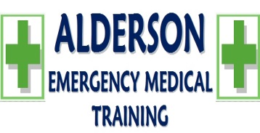  S. Alderson Emergency Medical Training (Pty) Ltd | PROTECTION OF PERSONAL INFORMATION ACT 4, 2013  (As of 1st July 2021) | Doc. No GENF 024  Rev. No.: 0
Prepared by:  C. Alderson  Quality Management Representative | Approved by:  S. Alderson  CEO | Date:  2021/06/01

PROTECTION OF PERSONAL INFORMATION ACT 4, 2013
(Herein as POPI Act, as of 1st July 2021)
Personal information to be used for MerSeta only purposes – full Policy and Procedure available on request
Name & Surname:
ID:
Address
Cell:
Signature:
Name of Intuition:
Reason for using personal information:

Agree that the following information has been discussed with me and I understand and agree to the terms laid out.
 | Accountability – the responsible party | Yes | No
 | Processing limitation – strict controls to lawfully process data | Yes | No
 | Purpose specification – limits the data they have collected | Yes | No
 | Further processing limitation – how they can and can’t process data | Yes | No
 | Information quality – must be accurate and complete | Yes | No
 | Openness – their responsibility to know where they collect data from | Yes | No
 | Security safeguards – Security measures in place | Yes | No
 | Data subject participation – The rights of the data subject | Yes | No

I, ________________________________ the undersigned declare that the above is true and correct at the time of completing this form. And give full consent to use my personal information for Data upload purposes for MerSeta.

Signature |  | Date: |  | Witness

